Part 3 - Predictive Modeling using Spark ML
Project Title - Financial Forecasting Frontier: Distributed Machine Learning for Banking Analytics

Objective
The objective of this phase is to develop scalable machine learning models using Apache Spark ML to predict whether a customer will subscribe to a term deposit based on demographic, financial, and marketing campaign information.
Unlike traditional machine learning libraries that operate on a single machine, Spark ML distributes model training and prediction across multiple partitions, making it suitable for handling large banking datasets efficiently.

Problem Statement
Banks conduct marketing campaigns to encourage customers to subscribe to financial products such as term deposits. Contacting every customer is both expensive and inefficient. Therefore, predictive analytics is used to identify customers who are more likely to respond positively to a campaign.
The goal of this predictive modeling phase is to build machine learning models capable of classifying customers into:
- Yes – Customer is likely to subscribe.
- No – Customer is unlikely to subscribe.
This enables banks to focus marketing efforts on high-potential customers, reducing costs and improving campaign success rates.

Apache Spark ML
Apache Spark ML is Spark’s distributed machine learning library that supports:
- Distributed model training
- Feature engineering
- Machine learning pipelines
- Hyperparameter tuning
- Cross-validation
- Model evaluation
Spark ML allows training on datasets that are much larger than what can fit into the memory of a single machine.

Data Preparation
Before training the models, the banking dataset undergoes several preprocessing steps.
These include:
- Handling missing values
- Encoding categorical variables
- Indexing labels
- Feature transformation
- Vector assembly
- Feature scaling (where applicable)
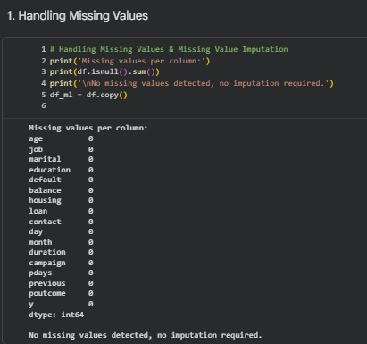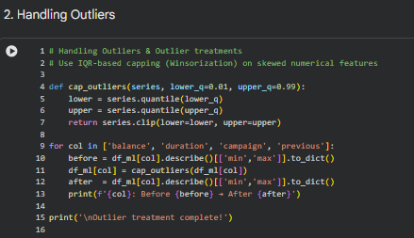
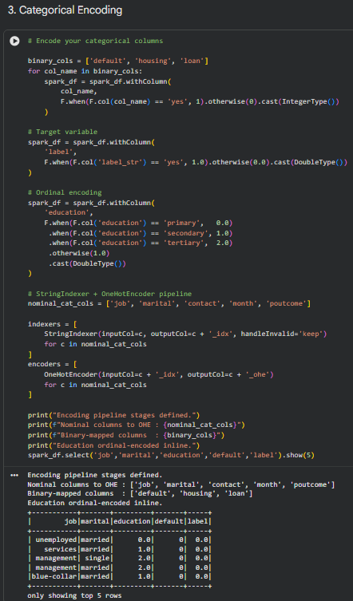
The processed features are combined into a single feature vector, which serves as input to the machine learning algorithms.

Feature Engineering
Feature engineering is performed using Spark ML Pipeline components.
The workflow includes:
- StringIndexer for categorical variables
- OneHotEncoder for converting categorical features into numerical vectors
- VectorAssembler for combining all features
- Pipeline for automating preprocessing and model training
Using pipelines ensures that preprocessing and model training remain consistent throughout the workflow.

Train-Test Split
The dataset is divided into:
- Training Dataset
- Testing Dataset
The training dataset is used to build the predictive models, while the testing dataset is used to evaluate model performance on unseen data.
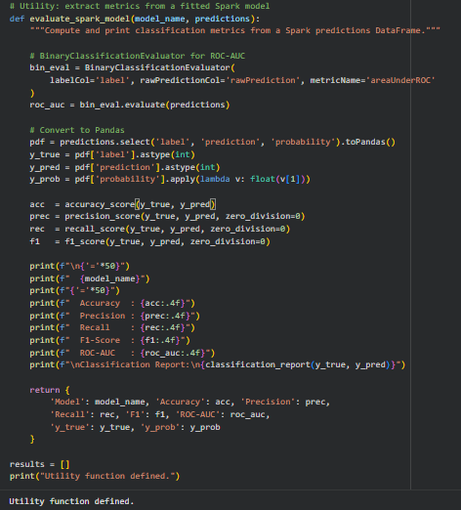
This helps measure how well the model generalizes to new customer data.

Handling Class Imbalance
The target variable is highly imbalanced, with significantly more customers who did not subscribe than those who did.
To address this issue:
- Class weighting is applied during model training.
- Evaluation focuses on ROC-AUC, Precision, Recall, and F1-score rather than relying solely on Accuracy.
This approach improves the model’s ability to correctly identify minority-class customers.

Machine Learning Models
Three different classification algorithms are implemented and compared.
1. Logistic Regression
Logistic Regression serves as the baseline classification model.
Advantages:
- Fast training
- Simple interpretation
- Good baseline performance
- Suitable for binary classification
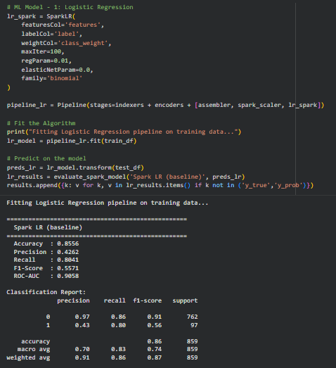
It estimates the probability that a customer will subscribe to a term deposit.

2. Random Forest Classifier
Random Forest is an ensemble learning algorithm that combines multiple decision trees.
Advantages:
- Handles nonlinear relationships
- Robust against overfitting
- Works well with mixed data types
- Provides feature importance scores
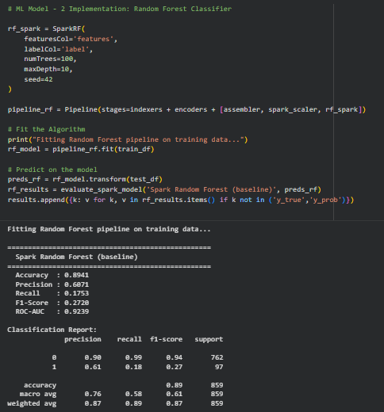
Random Forest generally performs better than a single decision tree due to ensemble voting.

3. Gradient-Boosted Trees (GBT)
Gradient-Boosted Trees improve predictive performance by sequentially correcting errors made by previous trees.
Advantages:
- High predictive accuracy
- Captures complex patterns
- Handles nonlinear relationships effectively
- Often performs well on structured datasets
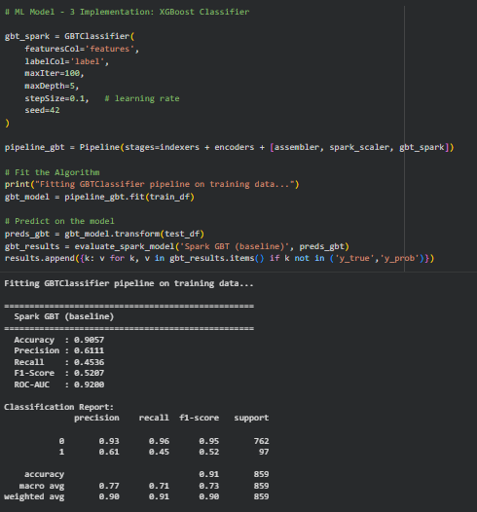
GBT is particularly useful for banking classification problems where customer behavior depends on multiple interacting factors.

Hyperparameter Tuning
To improve model performance, hyperparameter tuning is performed using Spark ML’s CrossValidator.
Several combinations of model parameters are evaluated automatically.
The model with the best validation performance is selected for final prediction.
This process improves robustness and reduces the risk of overfitting.

Cross Validation
A 5-fold Cross Validation strategy is used.
The training dataset is divided into five subsets.
During each iteration:
- Four subsets are used for training.
- One subset is used for validation.
This process is repeated five times.
The average performance across all folds determines the best-performing model.
Cross-validation provides a more reliable estimate of model performance than a single train-test split.

Model Evaluation Metrics
Several evaluation metrics are used to assess classification performance.
Accuracy
Measures the percentage of correctly classified customers.
Although useful, accuracy alone can be misleading for imbalanced datasets.

Precision
Precision measures how many customers predicted as subscribers actually subscribed.
Higher precision reduces false-positive predictions.

Recall
Recall measures how many actual subscribers are correctly identified.
In banking, high recall ensures that valuable customers are not missed during marketing campaigns.

F1-Score
F1-score balances Precision and Recall.
It is particularly useful when dealing with imbalanced datasets.

ROC-AUC
Receiver Operating Characteristic – Area Under Curve (ROC-AUC) evaluates how effectively the model distinguishes between subscribing and non-subscribing customers.
Higher ROC-AUC values indicate better classification performance.

Model Comparison
The three machine learning models are compared using the evaluation metrics.
Comparison focuses on:
- Prediction accuracy
- ROC-AUC
- Precision
- Recall
- F1-score
- Training efficiency
The best-performing model is selected for deployment based on overall predictive performance rather than a single metric.

Business Insights
The predictive models identify several important factors influencing customer subscriptions.
Key findings include:
- Longer call duration is strongly associated with successful subscriptions.
- Customers with successful previous campaign outcomes are more likely to subscribe again.
- Housing loan status influences marketing responses.
- Occupation and education level affect subscription probability.
- Previous customer interactions significantly improve prediction accuracy.
These insights help banks optimize marketing campaigns and allocate resources more effectively.

Advantages of Spark ML
Spark ML provides several advantages for large-scale banking analytics.
- Distributed model training
- Faster processing of large datasets
- Integrated preprocessing pipelines
- Built-in hyperparameter tuning
- Efficient cross-validation
- Seamless integration with Spark SQL and Spark Streaming
- Scalability for production environments

Challenges Faced
Several challenges were encountered during predictive modeling.
- Managing class imbalance in the target variable.
- Selecting appropriate evaluation metrics.
- Configuring Spark ML pipelines.
- Tuning hyperparameters efficiently.
- Balancing model complexity with execution time.
- Preventing overfitting while maintaining prediction accuracy.

Learning Outcomes
This phase provided practical experience in:
- Distributed machine learning with Apache Spark.
- Feature engineering using Spark ML Pipelines.
- Hyperparameter tuning using CrossValidator.
- Evaluating classification models using multiple metrics.
- Handling imbalanced banking datasets.
- Building scalable predictive analytics systems.

Conclusion
The predictive modeling phase successfully demonstrated how Apache Spark ML can be used to build scalable and efficient machine learning models for banking analytics. Three classification algorithms—Logistic Regression, Random Forest, and Gradient-Boosted Trees—were developed, evaluated, and compared using distributed machine learning techniques. The resulting models provide valuable insights into customer subscription behavior and support data-driven decision-making for targeted banking campaigns.

